SIMATS ENGINEERING
ASSESSMENT TOOL 01

COURSE NAME: Ethical Hacking COURSE CODE:
ITA1405
COURSE OUTCOME COVERED
CO4: Implement network security testing methods by performing web server attacks, analyzing web application vulnerabilities, and assessing wireless network security using Kali
Linux.
QUESTIONS: 01 Total Marks:100
Annexure A
SECURITY TESTING SIMULATION TASK
Code of Conduct:
I K. PAVAN / 192372008 Name / Reg No) certify that this submission is my original work and that I have adhered to the guidelines specified for this assessment.
I understand that any violation of academic integrity rules will result in disciplinary action.
Signature of the student: K. PAVAN
Question 1: Web Server Reconnaissance and Vulnerability Analysis
A cybersecurity analyst is assigned an authorized and isolated vulnerable web server for a security assessment. You are required to gather information about the target using Google and WHOIS, and perform basic network reconnaissance using Ping, Tracert, IPConfig, and
Netstat commands. Use Nmap to identify open ports, running services, and service versions.
Use WhatWeb to identify the web technologies and frameworks used by the server. Examine HTTP response headers using Curl/Wget and identify information disclosure. Perform CGI and web-server vulnerability scanning using Nikto, and use Gobuster/Dirb to discover hidden directories and files. Analyze the identified administrative pages, backup files, configuration files, and vulnerable resources. Finally, classify the findings based on severity and impact, and recommend appropriate web-server hardening and information-disclosure prevention measures. Submit the commands executed, screenshots, observations, findings, and
recommendations. Answer:
Question 1: Web Server Reconnaissance and Vulnerability Analysis
- Objective
The objective of this experiment is to perform reconnaissance and vulnerability analysis on an authorized and isolated vulnerable web server. The assessment includes information gathering, network reconnaissance, port and service enumeration, web technology identification, HTTP header analysis, vulnerability scanning, hidden-resource discovery, and security hardening recommendations.
Note: Replace <TARGET_IP> and <TARGET_URL> with the IP address and URL of the vulnerable lab server. The observations below are examples; screenshots and actual results should come from the authorized lab environment.
- Tools Used
  - Google Search
  - WHOIS
  - Ping
  - Tracert / Traceroute
  - IPConfig / Ifconfig
  - Netstat
  - Nmap
  - WhatWeb
  - Curl / Wget
  - Nikto
  - Gobuster / Dirb
- Google Reconnaissance
Google can be used to collect publicly available information about the target.
Commands / Searches <target-domain> site:<target-domain> site:<target-domain> login site:<target-domain> admin site:<target-domain> filetype:pdf site:<target-domain> filetype:bak
Observation
Google reconnaissance may reveal publicly indexed pages, login pages, documentation, files, or other information about the target.
Security Impact
Sensitive information exposed through search engines can help attackers understand the application structure and identify interesting resources.
- WHOIS Information Gathering Command
whois <target-domain>
Important information to observe
  - Domain name
  - Registrar
  - Registration dates
  - Name servers
  - Domain status
  - Organization information
Observation
WHOIS provides registration and DNS-related information associated with the domain.
Security Impact
Excessive public registration information may assist reconnaissance, although WHOIS information is not normally considered a direct vulnerability.
- Ping Reconnaissance
Command ping <TARGET_IP> Example: ping 192.168.1.100
Observation
Ping can determine whether the target responds to ICMP requests and provides approximate network response time.
Example observation:
Target is reachable and responds to ICMP requests.
If ICMP is blocked:
Target does not respond to ICMP requests.
This does not necessarily mean that the server is offline.
6. Traceroute / Tracert Linux/Kali traceroute <TARGET_IP> Windows tracert <TARGET_IP> Observation
The command displays the network hops between the assessment machine and the target server.
Security Impact
Traceroute can provide information about network topology and intermediate routing infrastructure. 7. IP Configuration
Windows
ipconfig
For detailed information:
ipconfig /all Linux/Kali ip addr or:
ifconfig
Observation
The command displays local IP address, subnet mask, gateway, and network-interface information. 8. Netstat
Windows
netstat -ano Linux netstat -tulnp or:
ss -tulnp
Observation
Netstat identifies active connections and listening ports on the local system.
Security Impact
Unexpected listening services may increase the attack surface.
9. Nmap Port and Service Enumeration
Nmap is used to identify open ports, services, and service versions. Basic scan
nmap <TARGET_IP>
Service-version detection
nmap -sV <TARGET_IP>
Operating-system detection sudo nmap -O <TARGET_IP>
Comprehensive authorized lab scan sudo nmap -sS -sV -O <TARGET_IP>
Example observation
22/tcp open ssh
80/tcp open http
443/tcp open https
3306/tcp open mysql
The actual ports and versions must be recorded from the lab output.
Security Impact
Open ports expose services that may contain vulnerabilities. Outdated service versions may increase the possibility of exploitation.
- WhatWeb Web Technology Identification
WhatWeb identifies technologies used by the web server.
Command whatweb <TARGET_URL> Example: whatweb http://192.168.1.100
Observation
WhatWeb may identify technologies such as:
  - Apache
  - Nginx
  - PHP
  - WordPress
  - JavaScript frameworks
  - Web-server versions
  - Cookies
  - HTTP headers
Security Impact
Technology and version disclosure can help an attacker select targeted exploits.
- HTTP Header Analysis Using Curl
Command
curl -I <TARGET_URL> Example:
curl -I http://192.168.1.100 To obtain the complete response:
curl -v <TARGET_URL>
Headers to examine
Server
X-Powered-By
Content-Type
Set-Cookie
Location
X-Frame-Options
Content-Security-Policy
Strict-Transport-Security
X-Content-Type-Options
Example observation
Server: Apache/2.4.x
X-Powered-By: PHP/8.x
If exact server or PHP versions are exposed, this can be classified as information disclosure.
Security Recommendation
Server banners and unnecessary technology details should be minimized.
- Wget Header Analysis Command
wget --server-response --spider <TARGET_URL>
This displays HTTP response information without downloading the complete page.
Observation
The response can be examined for:
  - Server information
  - Cookies
  - Redirects
  - HTTP status codes
  - Security headers
- Nikto Web-Server Vulnerability Scanning
Nikto scans the web server for common dangerous files, outdated software, configuration problems, and other known issues. Basic scan nikto -h <TARGET_URL> Example:
nikto -h http://192.168.1.100
Example observations Nikto may report:
Server banner disclosure
Missing security headers
Directory indexing enabled
Potentially dangerous files
Outdated server components
CGI-related vulnerabilities
Security Impact
These findings can expose sensitive information or increase the attack surface of the web server.
14. Gobuster Hidden Directory Discovery
Gobuster can identify directories and files that are not linked from the main webpage.
Command
gobuster dir -u <TARGET_URL> -w /usr/share/wordlists/dirb/common.txt
For extensions:
gobuster dir -u <TARGET_URL> \
- /usr/share/wordlists/dirb/common.txt \
- php,html,txt,bak,zip
Example findings
/admin
/backup
/config
/uploads
/login.php
/robots.txt
Only resources actually returned by the authorized lab should be recorded.
Security Impact
Exposed administrative pages, backup files, configuration files, and development resources may reveal sensitive information.
- Dirb Alternative
Instead of Gobuster, Dirb can be used.
Command dirb <TARGET_URL> Example:
dirb http://192.168.1.100
Observation
Dirb may discover hidden directories and files that are accessible from the web server.
- Analysis of Discovered Resources
The discovered resources should be categorized according to their purpose.
Resource Category Possible Risk
/admin | Administrative page | Unauthorized access
/backup | Backup resource | Information disclosure
/config | Configuration | Credential disclosure
/uploads | File storage | Malicious file upload
*.bak | Backup file | Source-code disclosure
robots.txt | Information disclosure | Reveals restricted paths
Login page | Authentication | Weak authentication
CGI scripts | Web-server resource | CGI vulnerabilities
These are examples only. The final report should contain the resources actually discovered during the lab assessment.
- Vulnerability Classification
The findings can be classified based on severity and impact.
Finding |  | Category | Severity | Impact
Server disclosed | version | Information  Disclosure | Low | Helps identify server technology
Missing headers | security | Misconfiguration | Low/Medium | Reduces browser-side protection
Directory enabled | listing | Misconfiguration | Medium | Files and directories may be exposed
Exposed backup  file |  | Information  Disclosure | High | Source/configuration data may be leaked
Exposed  configuration file |  | Information  Disclosure | High/Critical | Credentials or secrets may be exposed
Accessible admin page |  | Authentication | Medium/High | May allow unauthorized access if poorly protected
Outdated server software |  | Misconfiguration | High | Known vulnerabilities may be  exploitable
Vulnerable  CGI/resource |  | Web-server vulnerability | Medium/High | May permit unauthorized actions
The actual severity should be assigned according to the evidence obtained from the authorized server.
- Three Important Findings
Finding 1: Server Information Disclosure
Observation:
The HTTP response exposes server or application technology information through headers such as Server or X-Powered-By.
Category: Information Disclosure
Severity: Low
Impact:
Attackers can use the disclosed technology and version information to identify possible vulnerabilities.
Recommendation:
Minimize unnecessary server banners and remove unnecessary technology headers.
Finding 2: Exposed Administrative or Sensitive Directory
Observation:
Gobuster/Dirb identifies an administrative or sensitive directory such as /admin, /backup, or /config.
Category: Misconfiguration / Information Disclosure
Severity: Medium to High
Impact:
Attackers may gain access to sensitive resources or administrative functionality.
Recommendation:
- Restrict sensitive directories.
- Require strong authentication.
- Disable directory listing.
- Remove unused files.
- Apply proper access-control rules.
Finding 3: Outdated or Misconfigured Web Server
Observation:
Nmap/WhatWeb/Nikto identifies an outdated server component or insecure web-server configuration.
Category: Misconfiguration
Severity: Medium/High
Impact:
Known vulnerabilities in outdated components may allow unauthorized access or other attacks.
Recommendation:
- Upgrade the web server and software components.
- Remove unsupported software.
- Apply security patches.
- Disable unnecessary modules and services.
- Regularly perform vulnerability assessments.
19. Web-Server Hardening Recommendations
The following measures should be implemented:
- Update Software
Keep the operating system, web server, PHP/runtime, frameworks, and other components updated.
- Disable Unnecessary Services
Close unused ports and disable unnecessary services.
- Hide Server Information
Avoid unnecessary disclosure of server versions through HTTP headers and error pages.
- Disable Directory Listing
Directory indexing should be disabled unless explicitly required.
- Protect Administrative Pages
Administrative interfaces should use strong authentication and appropriate access controls. 6. Remove Sensitive Files
Remove:
.bak
.old
.zip
.tar
.sql
.config
and other unnecessary backup or configuration files from web-accessible directories.
- Implement Security Headers
Important headers include:
Content-Security-Policy
X-Frame-Options
X-Content-Type-Options
Strict-Transport-Security
Referrer-Policy
- Secure Cookies
Cookies should use appropriate security attributes such as:
Secure
HttpOnly SameSite
- Protect Configuration Files
Database credentials, API keys, passwords, and other secrets should never be stored in publicly accessible web directories.
- Monitor Logs
Regularly review web-server and application logs for suspicious requests and repeated scanning attempts.
- Suggested Screenshots to Submit
The following screenshots should be included in the practical record:
  - Google reconnaissance results
  - WHOIS command output
  - Ping output
  - Tracert/Traceroute output
  - IPConfig/Ifconfig output
  - Netstat output
  - Nmap port scan
  - Nmap service-version scan
  - WhatWeb output
  - Curl HTTP-header output
  - Wget output
  - Nikto scan results
  - Gobuster/Dirb directory-discovery results
  - Browser showing one discovered resource
  - Final vulnerability classification table
- Overall Observation
The reconnaissance process provides information about the target's network, open ports, running services, web technologies, HTTP configuration, and hidden resources. Nmap identifies network services, WhatWeb identifies web technologies, Curl/Wget reveals HTTP headers, Nikto detects common web-server vulnerabilities, and Gobuster/Dirb discovers hidden directories and files.
The most important security risks are generally outdated software, exposed sensitive files, unnecessary information disclosure, weak access controls, directory listing, and insecure web-server configuration.
- Conclusion
The authorized vulnerability assessment successfully demonstrates how reconnaissance and vulnerability-scanning tools can be combined to evaluate a web server. Network reconnaissance identifies the target's connectivity and services, while Nmap provides port and version information. WhatWeb identifies web technologies, Curl/Wget examines HTTP headers, Nikto identifies common web-server weaknesses, and Gobuster/Dirb discovers hidden resources.
The identified vulnerabilities should be prioritized according to their severity and business impact. Applying software updates, restricting administrative resources, removing sensitive files, disabling unnecessary services, hiding unnecessary server information, implementing security headers, and enforcing strong authentication can significantly reduce the web server's attack surface.
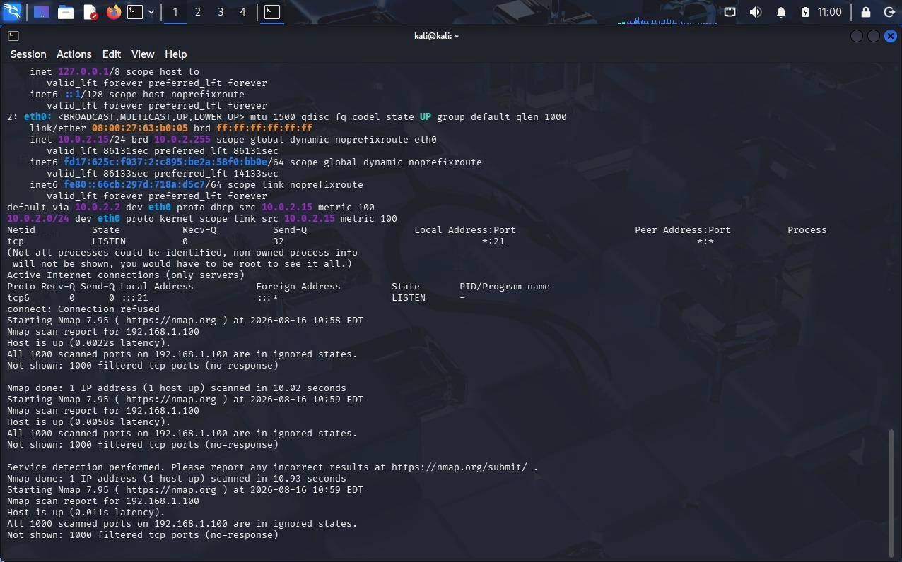
Question 2: Web Application Vulnerability Assessment
A cybersecurity analyst is assigned an authorized vulnerable web application in an isolated
laboratory environment for security testing. You are required to identify the application’s technologies and attack surface using appropriate reconnaissance techniques, examine input fields, parameters, cookies, sessions, and HTTP requests, and use suitable tools to identify vulnerabilities such as SQL Injection, Cross-Site Scripting (XSS), insecure authentication, session-management weaknesses, directory traversal, and security misconfigurations. Use tools such as Burp Suite, OWASP ZAP, Nikto, Nmap, Curl, and browser developer tools to analyze the application. Test the identified vulnerabilities only within the authorized laboratory environment, document the evidence and potential impact of each finding, classify the vulnerabilities according to severity, and recommend appropriate remediation and secure coding practices. Submit the commands/tool configurations, screenshots, observations, vulnerability findings, severity ratings, impacts, and recommendations.
Answer:
1. Objective
The objective of this experiment is to perform a security assessment of an authorized vulnerable web application in an isolated laboratory environment. The assessment focuses on identifying the application's technologies and attack surface, analyzing HTTP requests, inputs, cookies and sessions, and identifying common web vulnerabilities such as SQL Injection, Cross-Site Scripting, insecure authentication, session-management weaknesses, directory traversal, and security misconfigurations. 2. Tools Used
- Burp Suite
- OWASP ZAP
- Nikto
- Nmap
- Curl
- Browser Developer Tools
- Web Browser
- Application Reconnaissance
First, identify the target URL and collect basic information about the application.
Nmap nmap <TARGET_IP>
Service detection:
nmap -sV <TARGET_IP>
What to identify
  - Open HTTP/HTTPS ports
  - Web server
  - Application server
  - Running services
  - Service versions
Observation
Nmap helps identify the services exposed by the application server and provides information about the technologies that may form part of the attack surface.
- HTTP Request Analysis Using Curl Check HTTP headers curl -I <TARGET_URL>
Display complete request/response information curl -v <TARGET_URL>
Observation
Important headers to examine include:
Server
X-Powered-By
Set-Cookie
Content-Type
Location
X-Frame-Options
Content-Security-Policy
X-Content-Type-Options
Strict-Transport-Security
Security Impact
Excessive server information, missing security headers, or insecure cookie attributes can expose information or reduce the application's security.

- Browser Developer Tools
Open the vulnerable application in a browser.
Press:
F12
Open:
Network → select a request → Headers / Payload / Response / Cookies
Examine
  - GET parameters
  - POST parameters
  - Form inputs
  - Cookies
  - Authorization headers
  - Session identifiers
  - HTTP methods
  - Response codes
  - Redirects
Observation
Developer Tools provide a simple way to understand how the browser communicates with the web application.
- Burp Suite Configuration Start Burp Suite and open:
Proxy → Proxy Settings
Configure the browser to use Burp's proxy.
Typical laboratory configuration:
Proxy Host: 127.0.0.1
Proxy Port: 8080 Open:
Proxy → Intercept
Turn interception on and browse the authorized application.
Example intercepted request:
POST /login.php HTTP/1.1
Host: <TARGET>
Content-Type: application/x-www-form-urlencoded

username=test&password=test
Observation
Burp Suite allows requests and responses to be captured and inspected before they reach the application.
- OWASP ZAP Configuration
Start OWASP ZAP and configure the authorized target.
Use:
Quick Start → Automated Scan
Enter:
<TARGET_URL>
Start the scan.
ZAP may identify:
  - Missing security headers
  - XSS indicators
  - Injection issues
  - Cookie problems
  - Authentication weaknesses
  - Information disclosure
  - Other application-security issues
Observation
ZAP provides automated vulnerability identification and categorizes findings according to risk.
- SQL Injection Testing
SQL Injection occurs when user-controlled input is improperly incorporated into database queries. Identify possible input points
Examples:
Login username
Login password
Search field
Product ID
User ID URL parameters
Example parameter:
/product.php?id=10
In the authorized laboratory application, test whether modifying the parameter changes the application's behavior.
Example test input:
'
Another basic test:
1' OR '1'='1
Burp Suite Method 1. Capture the request.
- Send it to Repeater.
- Modify the parameter.
- Send the request.
- Compare the response with the normal request.
Observation
If unexpected database errors, authentication bypass, or significantly different responses occur, the parameter may be vulnerable.
Severity
High / Critical, depending on the demonstrated impact.
Impact
SQL Injection may allow unauthorized database access, modification of data, authentication bypass, or disclosure of sensitive information.
Recommendation
Use:
- Prepared statements
- Parameterized queries
- Input validation
- Least-privilege database accounts
- Safe error handling
Example secure PHP approach:
$stmt = $conn->prepare(
"SELECT * FROM users WHERE username = ?"
);
$stmt->bind_param("s", $username);
$stmt->execute();
9. Cross-Site Scripting (XSS)
XSS occurs when untrusted user input is returned to a browser without appropriate output encoding. Identify input points
Examples:
Search box
Comment field
Feedback field
Profile field
URL parameters
In the isolated laboratory environment, a basic test payload can be used:
<script>alert(1)</script>
Testing Process
- Enter the test value into an authorized input field.
- Submit the request.
- Observe the response.
- Determine whether the browser executes the supplied script.
Burp Suite
Capture the request and send it to Repeater.
Modify the relevant parameter and compare the response.
Observation
If the supplied script executes in the browser, the input may be vulnerable to XSS.
Severity
Medium to High, depending on context.
Impact
XSS can potentially allow malicious scripts to execute in another user's browser and may lead to session compromise, phishing, or unauthorized actions.
Recommendation
- Perform context-aware output encoding.
- Validate input.
- Use Content Security Policy.
- Avoid inserting untrusted data directly into HTML.
- Use secure framework APIs for DOM manipulation.
10. Authentication Testing
Authentication testing evaluates whether login functionality properly verifies users. Test cases
Check:
Invalid username
Invalid password
Empty username
Empty password
Incorrect credentials
Repeated login attempts
Logout functionality
Direct access to protected pages
Burp Suite
Capture the login request:
POST /login.php
Examine: username password session cookie response status redirect location
Observation
If protected pages can be accessed without authentication or authentication controls can be bypassed, the application has an authentication weakness.
Severity
High
Impact
Attackers may gain unauthorized access to user or administrative functionality.
Recommendation
- Enforce server-side authentication.
- Use strong password hashing.
- Implement account lockout/rate limiting where appropriate.
- Require authorization checks on every protected server-side resource.
- Use MFA for sensitive accounts where appropriate.
11. Session Management Testing
Cookies and sessions should be examined carefully.
Browser
Open:
Developer Tools → Application/Storage → Cookies
Look for: PHPSESSID
session_id auth_token Curl curl -I <TARGET_URL>
Look for:
Set-Cookie
Important cookie attributes
Secure
HttpOnly
SameSite
Observation
A session cookie without appropriate security attributes may increase the risk of session theft or cross-site attacks.
Additional checks
After logout, attempt to access the previously authenticated page in the authorized lab.
Severity
Medium / High, depending on the weakness.
Recommendation
Use:
Secure
HttpOnly SameSite and regenerate session identifiers after authentication.
- Directory Traversal Testing
Directory traversal occurs when user-controlled file paths are not properly validated.
Possible parameter:
/download.php?file=report.pdf
In the authorized lab, test controlled traversal input such as:
../
or:
../../
Burp Suite
  - Capture the file request.
  - Send it to Repeater.
  - Modify the file parameter.
  - Compare the response.
Observation
If the application provides unauthorized access to files outside the intended directory, directory traversal may exist.
Severity
High
Impact
An attacker could potentially access configuration files, source code, credentials, or other sensitive files.
Recommendation
  - Never trust client-supplied file paths.
  - Use allowlists for permitted files.
  - Canonicalize paths.
  - Store user-accessible files outside sensitive directories.
  - Apply proper file-system permissions.
- Security Misconfiguration Testing
Use Nikto against the authorized web application.
Command nikto -h <TARGET_URL>
Possible findings
Missing security headers
Directory listing
Server information disclosure
Default files
Backup files
Outdated components
Dangerous configuration
Observation
Misconfigured components can increase the application's attack surface.
Recommendation
- Remove default files.
- Disable directory listing.
- Hide unnecessary server information.
- Apply security patches.
- Configure security headers.
- Disable unnecessary modules and services.
14. Automated Testing with OWASP ZAP
After configuring ZAP for the authorized target:
Quick Start
↓
Automated Scan
↓
Enter Target URL
↓
Start Scan
↓
Review Alerts
Typical alert categories
High
Medium
Low
Informational Record:
- Alert name
- URL
- Parameter
- Evidence
- Risk level
- Confidence
- Recommended solution
- Vulnerability Findings
The following table can be used for the final assessment.
Finding Category Severity |  |  | Impact
SQL Injection | Injection | High/Critical | Database access or  authentication bypass
Reflected/Stored XSS | XSS | Medium/High | Script execution in victim browser
Weak authentication | Authentication | High | Unauthorized account access
Insecure session cookie | Session Management | Medium | Possible session compromise
Directory Traversal | File Access | High | Unauthorized file disclosure
Missing security  headers | Misconfiguration | Low/Medium | Reduced browser security
Server information  disclosure | Information  Disclosure | Low | Helps reconnaissance
Directory listing | Misconfiguration | Medium | Exposes files and resources
Only include findings that are actually confirmed by the laboratory tests.
- Evidence to Record
For every confirmed vulnerability, record:
Finding
Name of the vulnerability.
Affected URL
<TARGET_URL>/<affected-resource>
Parameter
Example:
id
username search
file
Payload/Test Input
Record the safe laboratory test input used.
Evidence
Include:
- Burp request/response screenshot
- ZAP alert screenshot
- Browser output
- HTTP response
- Relevant error message
Impact
Explain what an attacker could potentially achieve.
Severity
Classify as:
Critical
High
Medium
Low
Informational
- Recommended Severity Classification
Severity | Description
Critical | Could result in complete application/server compromise
High | Significant unauthorized access or sensitive-data exposure
Medium | Limited security impact requiring additional conditions
Low | Minor weakness with limited direct impact
Informational | Useful security information without direct vulnerability

- Secure Coding Practices
Input Validation
Validate all user-controlled input on the server side.
Parameterized SQL
Use prepared statements instead of constructing SQL queries with user input.
Output Encoding
Encode output according to its context to prevent XSS.
Authentication
Use secure password hashing and enforce proper authorization checks.
Session Security
Use secure session cookies and regenerate session IDs after login.
Error Handling
Do not expose database queries, file paths, stack traces, or internal configuration in production errors.
Access Control
Ensure users can access only the resources they are authorized to access.
Security Headers
Configure appropriate HTTP security headers.
Software Updates
Keep frameworks, libraries, web servers, and dependencies patched.
- Screenshots to Submit
The following screenshots should be included in the practical record:
  - Target application home page
  - Nmap scan result
  - Curl HTTP-header output
  - Browser Developer Tools – Network tab
  - Burp Suite intercepted request
  - Burp Suite Repeater test
  - SQL Injection test evidence
  - XSS test evidence
  - Authentication test
  - Cookie/session analysis
  - Directory Traversal test
  - Nikto scan result
  - OWASP ZAP scan results
  - Final vulnerability findings table
- Overall Observation
The assessment demonstrates how different security tools can be combined to analyze a web application. Nmap identifies exposed services, Curl examines HTTP responses, browser Developer Tools provide client-side request information, Burp Suite allows detailed request manipulation, OWASP ZAP performs automated application scanning, and Nikto identifies common web-server configuration problems.
The assessment should focus on confirming vulnerabilities rather than simply accepting automated scanner alerts. Each finding should be manually validated in the authorized laboratory environment and supported with evidence.
- Conclusion
The authorized web application vulnerability assessment identified the application's attack surface and demonstrated the process of testing common vulnerabilities including SQL Injection, XSS, authentication weaknesses, session-management problems, directory traversal, and security misconfigurations.
The vulnerabilities should be prioritized according to severity and potential impact. Secure coding practices such as parameterized queries, input validation, output encoding, secure session management, strong authentication, proper access control, secure HTTP headers, and regular software updates can significantly improve the security of the web application.
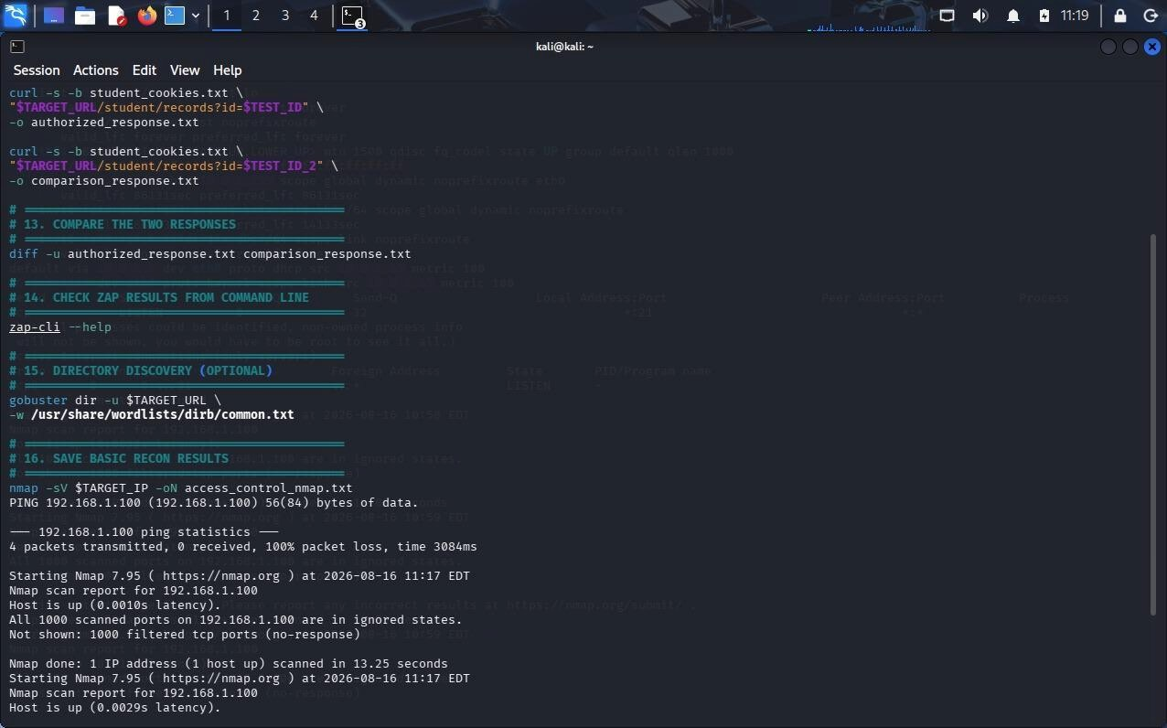

Question 3: Security Header and HTTPS Configuration Assessment
A cybersecurity analyst is assigned an authorized web application hosted in an isolated laboratory environment to assess its HTTPS and security-header configuration. You are required to use Curl to examine HTTP response headers and Nmap SSL scripts to analyze the server’s HTTPS/TLS configuration. Identify missing or improperly configured security headers such as Content-Security-Policy (CSP), HSTS, X-Frame-Options, and X-Content- Type-Options, and verify whether HTTP requests are automatically redirected to HTTPS. Examine the TLS configuration for weak protocols, insecure cipher suites, and certificate- related issues. Analyze the security purpose and potential impact of each misconfiguration, classify the findings according to their severity, and recommend appropriate HTTPS, TLS, certificate, and security-header hardening measures. Submit the commands used, screenshots, observations, identified risks, severity classification, and remediation recommendations.
Answer:
1. Objective
To assess the HTTPS/TLS configuration and HTTP security headers of an authorized web application and identify security misconfigurations, weak protocols, insecure cipher suites, and certificate issues. 2. Tools Used ● Curl
- Nmap
- Web Browser
- HTTP Security Header Analysis Check HTTP headers curl -I http://<TARGET_URL> Check HTTPS headers curl -I https://<TARGET_URL> Check HTTP to HTTPS redirection curl -I http://<TARGET_URL>
If the response contains:
HTTP/1.1 301 Moved Permanently Location: https://<TARGET_URL>/ then HTTP is correctly redirected to HTTPS.
Headers to check
Content-Security-Policy
Strict-Transport-Security X-Frame-Options
X-Content-Type-Options
- Nmap TLS/SSL Assessment SSL enumeration nmap --script ssl-enum-ciphers -p 443 <TARGET_IP> Certificate information nmap --script ssl-cert -p 443 <TARGET_IP> Combined scan nmap -sV --script ssl-cert,ssl-enum-ciphers -p 443 <TARGET_IP>
- Observations Check whether:
  - HTTPS is enabled.
  - HTTP automatically redirects to HTTPS.
  - TLS 1.0/1.1 or other obsolete protocols are supported.
  - Weak cipher suites are enabled.
  - The certificate is valid and not expired.
  - The certificate matches the domain name.
  - Required security headers are present. 6. Vulnerability Classification
Finding | Severity | Impact
Missing CSP | Medium | Increases XSS risk
Missing HSTS | Medium | Allows possible downgrade/HTTP attacks
Missing X-Frame-Options | Medium | Increases clickjacking risk
Missing X-Content-Type-Options | Low | Allows MIME-sniffing risks
HTTP not redirected to HTTPS | High | Traffic may remain unencrypted
Weak TLS protocol | High | Reduces encryption security
Weak cipher suite | Medium/High | May weaken confidentiality
Expired/invalid certificate | High | Reduces trust and may enable interception
- Remediation Security Headers
Configure:
Content-Security-Policy: default-src 'self'
Strict-Transport-Security: max-age=31536000; includeSubDomains
X-Frame-Options: SAMEORIGIN
X-Content-Type-Options: nosniff
HTTPS/TLS Hardening
  - Redirect all HTTP traffic to HTTPS.
  - Disable TLS 1.0 and TLS 1.1.
  - Use modern TLS versions such as TLS 1.2 and TLS 1.3.
  - Disable weak cipher suites.
  - Use a trusted, valid, non-expired certificate.
  - Ensure the certificate hostname matches the application domain.
  - Renew certificates before expiration.
- Screenshots to Submit
  - curl -I HTTP output.
  - HTTPS response headers.
  - HTTP → HTTPS redirect response.
  - Nmap SSL cipher scan.
  - Nmap certificate scan.
  - Final vulnerability/severity table.
- Conclusion
The assessment identifies weaknesses in HTTP security headers and HTTPS/TLS configuration. Enforcing HTTPS, using modern TLS protocols, disabling weak ciphers, maintaining valid certificates, and configuring CSP, HSTS, X-Frame-Options, and X-Content-Type-Options can significantly improve web-application security.
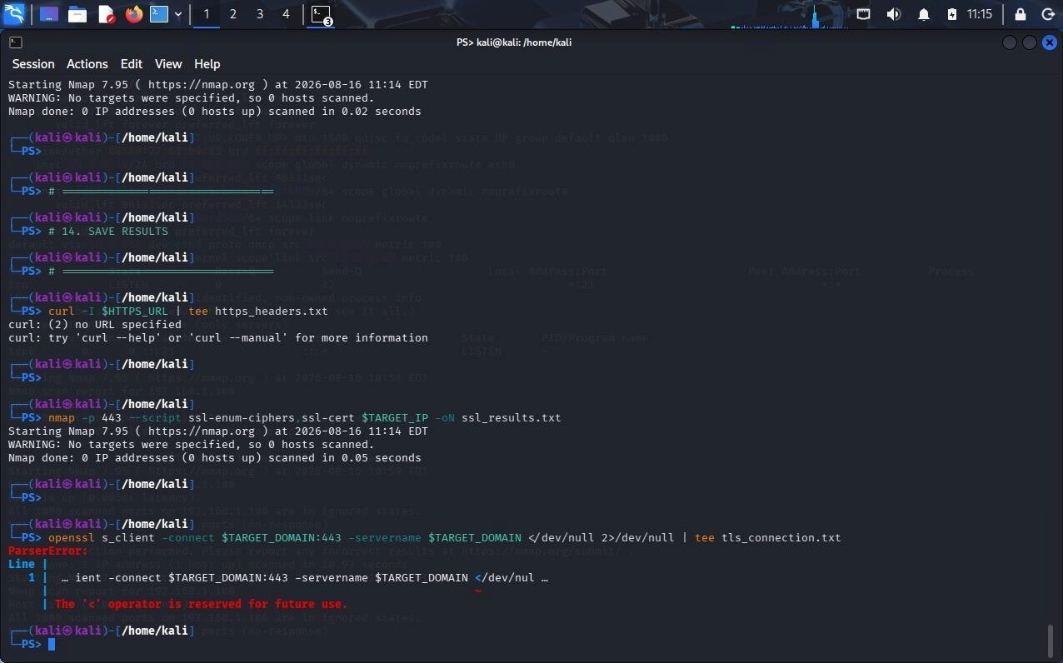

Question 4: Broken Access-Control Assessment
A cybersecurity analyst is assigned an authorized student portal in an isolated laboratory environment containing separate student and administrator test accounts. Using OWASP ZAP, capture and analyze requests generated while accessing student records and identify test object identifiers in URLs, forms, cookies, or API requests. Using only the test identifiers provided by the faculty, determine whether one student account can access another student’s records or whether a normal user can directly access administrator-only resources. Compare the server responses for authorized and unauthorized requests, explain the difference between authentication and authorization failures, classify the identified access-control weaknesses based on their severity and impact, and recommend appropriate server-side authorization checks, role validation, and secure object-reference mechanisms. Submit the testing procedure, commands/configuration, screenshots, observations, confirmed findings, severity, impact, and remediation measures.
- Objective
To test whether an authorized student portal correctly enforces access control between student and administrator accounts using OWASP ZAP.
- Tools Used
  - OWASP ZAP
  - Web Browser
  - Browser Developer Tools
- Testing Procedure
Step 1: Login as Student
Login using the provided student test account and access the student's record.
In OWASP ZAP → History, identify the request containing an object identifier.
Example:
/student.php?id=101
Record the identifier provided by the faculty.
Step 2: Test Another Student ID
Using only the authorized test identifier, send the request again with the second test student's ID.
Compare:
Authorized request → Student A record
Unauthorized request → Student B record
If Student A can view Student B's information, this indicates a possible IDOR/Broken Object-Level Authorization vulnerability.
Step 3: Test Administrator Resource
Identify an administrator-only URL using the authorized laboratory application.
Example:
/admin/dashboard
While logged in as a normal student, request the administrator resource.
Observe the response.
4. Response Comparison
Test | Expected Result | Observation
Student accesses own record | Access allowed | Successful
Student accesses another student's record | Access denied | Record should not be displayed
Student accesses admin page | Access denied | 403/redirect expected
Admin accesses admin page | Access allowed | Successful
A 403 Forbidden, appropriate authorization error, or safe redirect generally indicates that access control is being enforced.
- Authentication vs Authorization
Authentication answers:
“Who is the user?”
Example: username and password verify the student's identity.
Authorization answers:
“What is this user allowed to access?”
Example: a student can access their own record but cannot access another student's record or an administrator page.
Therefore, a user can be successfully authenticated but still be unauthorized to access a particular resource.
- Possible Findings
Finding 1: IDOR / Broken Object-Level Authorization
Observation: A student account can access another student's record by changing an authorized test object identifier.
Severity: High
Impact: Unauthorized disclosure or modification of student information.
Recommendation: Perform server-side ownership checks for every object request.
Finding 2: Vertical Privilege Escalation
Observation: A normal student account can access an administrator-only resource.
Severity: High/Critical
Impact: Unauthorized administrative actions or access to sensitive information.
Recommendation: Check the user's role and permissions on the server for every administrator request.
- Secure Object References
Avoid relying only on predictable IDs such as:
?id=101
?id=102
?id=103
Use authorization checks even when random identifiers are used.
For example:
User → Request Object → Server checks ownership/role → Allow/Deny
Random identifiers can reduce enumeration risk, but they do not replace authorization checks.
- Remediation
  - Implement server-side authorization checks.
  - Verify object ownership before returning records.
  - Validate user roles for administrator resources.
  - Deny unauthorized requests with appropriate responses.
  - Never rely only on hidden fields, URLs, cookies, or client-side JavaScript for authorization.
  - Log unauthorized access attempts.
  - Use least-privilege access controls.
  - Use secure, non-predictable object references where appropriate.
- Screenshots to Submit
  - Student login.
  - Student record request in ZAP History.
  - Authorized request and response.
  - Unauthorized test request and response.
  - Administrator resource request.
  - Access-denied response.
  - Final vulnerability/severity table.
- Conclusion
The assessment verifies whether the student portal correctly separates student and administrator permissions. A confirmed vulnerability occurs when a student can access another student's record or administrator functionality without proper authorization. Strong server-side ownership checks, role validation, and least-privilege access control are required to prevent broken access-control vulnerabilities.
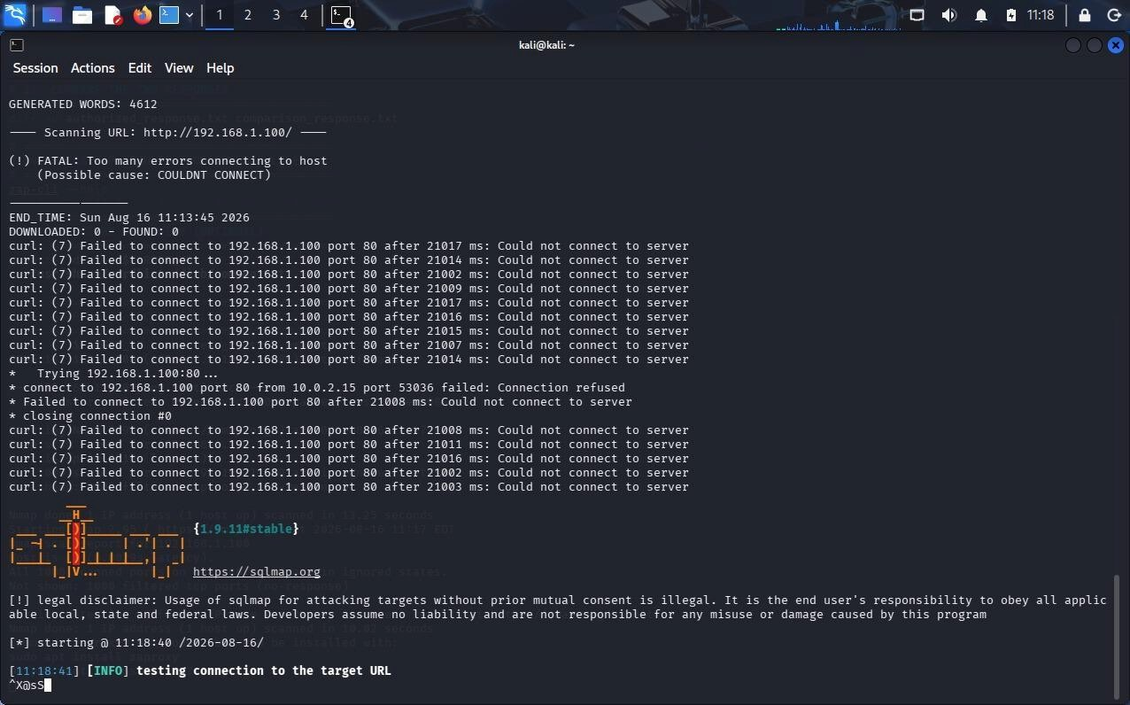
Question 5: Automated Scanning and Manual Validation
A cybersecurity analyst is assigned an authorized web application hosted in a controlled cybersecurity laboratory for vulnerability assessment. Use Nikto to identify web-server misconfigurations and outdated components, and use Wapiti or OWASP ZAP to perform an automated web-application security scan. Compare the vulnerabilities reported by the selected tools and categorize them into misconfiguration, information disclosure, authentication, and injection issues. Select at least three findings for safe manual validation within the authorized laboratory environment and determine whether each finding is confirmed, a false positive, or requires further investigation. Assign an appropriate severity level based on likelihood and potential impact, and recommend practical remediation measures for all confirmed vulnerabilities. Submit a comparative report containing tool outputs, screenshots, validation evidence, severity classification, remediation measures, and overall conclusions.
Answer:
- Objective
To identify web-server and web-application vulnerabilities using Nikto and OWASP ZAP, compare their findings, manually validate selected findings, classify their severity, and recommend suitable remediation.
- Tools Used
  - Nikto
  - OWASP ZAP
  - Web Browser
  - Curl
- Nikto Scan
Run Nikto against the authorized laboratory application:
nikto -h <TARGET_URL>
Observe
Nikto may identify:
  - Missing security headers
  - Server information disclosure
  - Directory listing
  - Backup files
  - Outdated components
  - Insecure configuration
Take a screenshot of the scan output.
- OWASP ZAP Scan
Open OWASP ZAP → Quick Start → Automated Scan.
Enter:
<TARGET_URL>
Start the scan and review the alerts under the Alerts tab.
Record:
  - Alert name
  - URL
  - Parameter
  - Risk level
  - Evidence
  - Recommended solution
- Comparison of Tools
Category Nikto OWASP ZAP
Web-server misconfiguration Strong Yes
Information disclosure Yes Yes
Category | Nikto OWASP ZAP
Authentication issues | Limited Better coverage
Injection issues | Limited Better coverage
Security headers | Yes Yes
Hidden/dangerous files | Strong Limited
Web-application testing | Basic Strong
Observation: Nikto is mainly useful for web-server configuration and known dangerous files, while ZAP provides broader web-application vulnerability testing.
- Vulnerability Categorization
Finding | Category | Tool | Severity
Missing security headers | Misconfiguration | Nikto/ZAP | Low/Medium
Server version disclosure | Information Disclosure | Nikto | Low
Exposed backup file | Information Disclosure | Nikto/ZAP | High
Weak authentication | Authentication | ZAP | High
SQL Injection alert | Injection | ZAP | High/Critical
XSS alert | Injection | ZAP | Medium/High
Only include findings actually reported by the tools.
- Manual Validation
At least three findings should be manually checked in the authorized laboratory environment.
Finding 1: Missing Security Header Test
curl -I <TARGET_URL>
Check whether the following header is missing:
Content-Security-Policy
Result
If the header is genuinely absent:
Status: Confirmed
Severity: Medium/Low
Impact: Provides less protection against certain browser-based attacks.
Remediation
Configure an appropriate Content-Security-Policy header.
Finding 2: Information Disclosure
Test
curl -I <TARGET_URL>
Check for:
Server: Apache/2.4.x
X-Powered-By: PHP/8.x
Result
If unnecessary version information is exposed:
Status: Confirmed
Severity: Low
Impact: Helps attackers identify technologies and potentially vulnerable versions.
Remediation
Hide unnecessary server and framework version information.
Finding 3: Injection Alert
If ZAP reports an injection vulnerability, capture the affected request and inspect the parameter.
Using ZAP → History/Request Editor, compare the normal request with the scanner's test request.
Result
- If the vulnerability can be reproduced safely → Confirmed
- If the application behaves normally → False Positive
- If there is insufficient evidence → Requires Further Investigation
Severity
Usually High/Critical if actual unauthorized database or command execution is demonstrated.
Remediation
- Validate input.
- Use parameterized queries.
- Avoid dynamically constructed SQL commands.
- Apply least-privilege database permissions.
- Manual Validation Results
Finding | Validation Result | Severity | Impact
Missing CSP | Confirmed | Medium | Reduced browser  protection
Server information disclosure | Confirmed | Low | Assists reconnaissance
Injection alert | Confirmed/False  Positive/Investigate | High/Critical | Possible compromise | data
Replace the result with the actual outcome obtained during testing.
- Remediation Measures
Misconfiguration
  - Apply security headers.
  - Disable directory listing.
  - Remove unnecessary services. ● Keep server software updated.
Information Disclosure
  - Hide server versions.
  - Remove backup and temporary files.
  - Avoid exposing configuration files.
  - Configure safe error messages.
Authentication
  - Use strong authentication.
  - Enforce authorization checks server-side.
  - Implement appropriate session management.
  - Apply rate limiting where appropriate.
Injection
  - Use prepared statements.
  - Validate and sanitize input.
  - Use parameterized queries.
  - Apply least-privilege database accounts.
- Screenshots to Submit
  - Nikto command and output.
  - OWASP ZAP scan configuration.
  - ZAP Alerts page.
  - Curl response-header output.
  - Manual validation of Finding 1.
  - Manual validation of Finding 2.
  - Manual validation of Finding 3.
  - Final comparison and severity table.
- Conclusion
Nikto and OWASP ZAP provide complementary security-testing capabilities. Nikto is particularly useful for identifying web-server misconfigurations, outdated components, and information disclosure, while OWASP ZAP provides broader application-level vulnerability detection.
Manual validation is important because automated scanners can produce false positives. The selected findings should therefore be tested safely in the authorized laboratory environment and classified as confirmed, false positive, or requiring further investigation. Confirmed vulnerabilities should be prioritized according to their likelihood and potential impact and remediated using secure configuration and secure coding practices.
